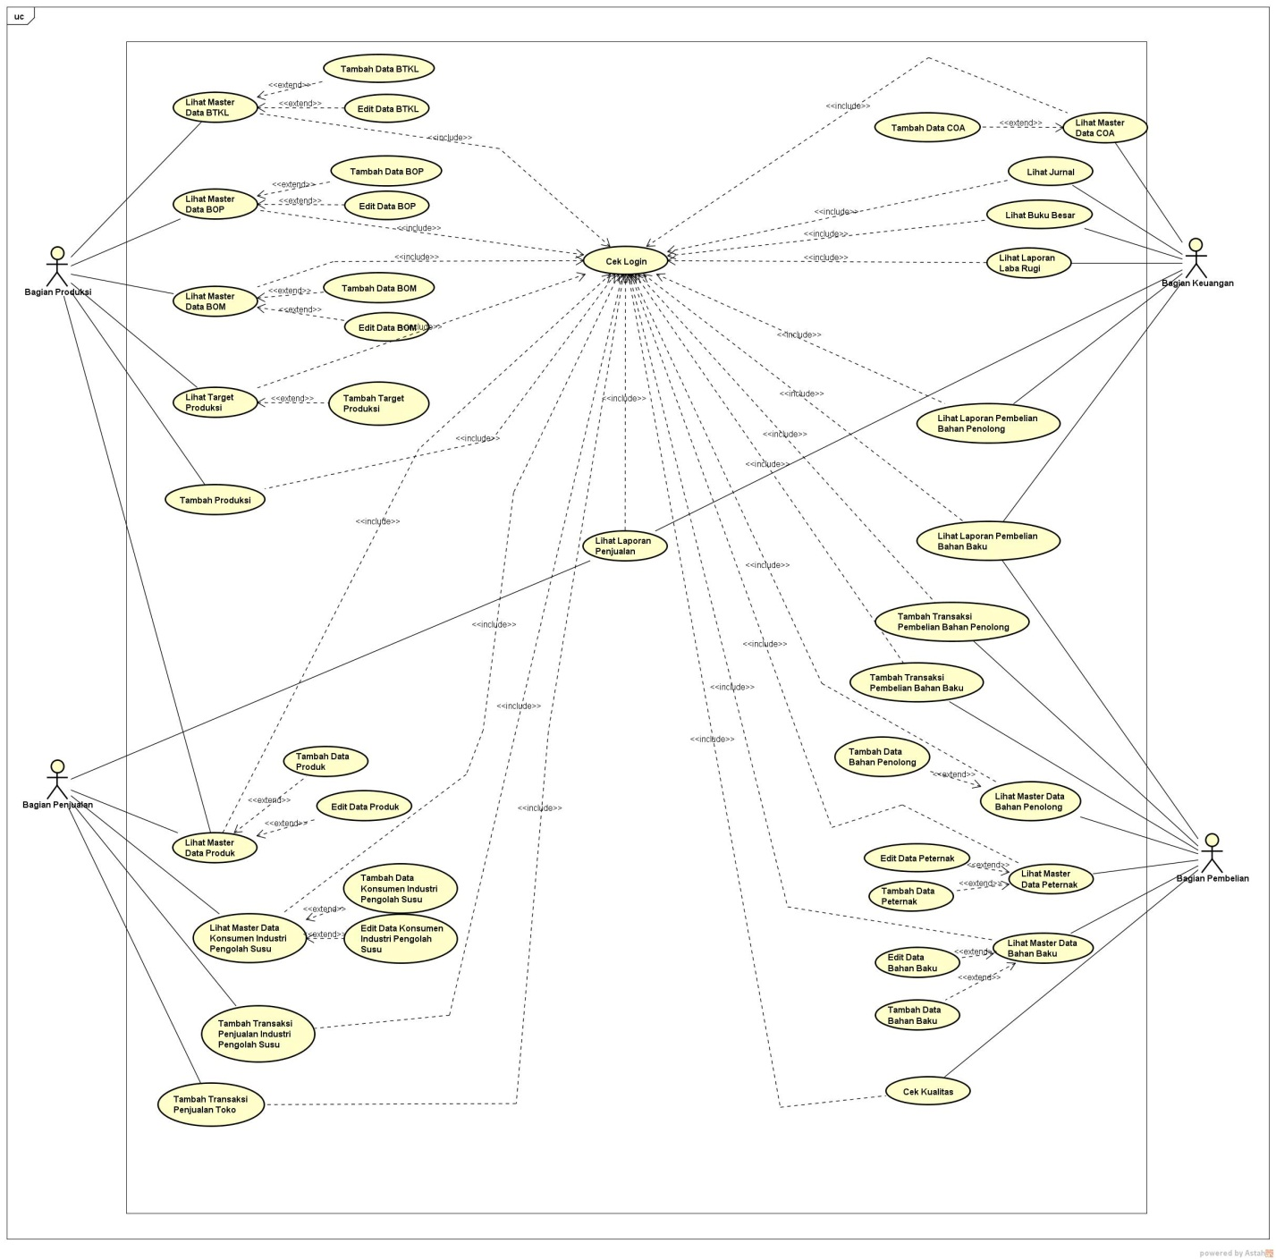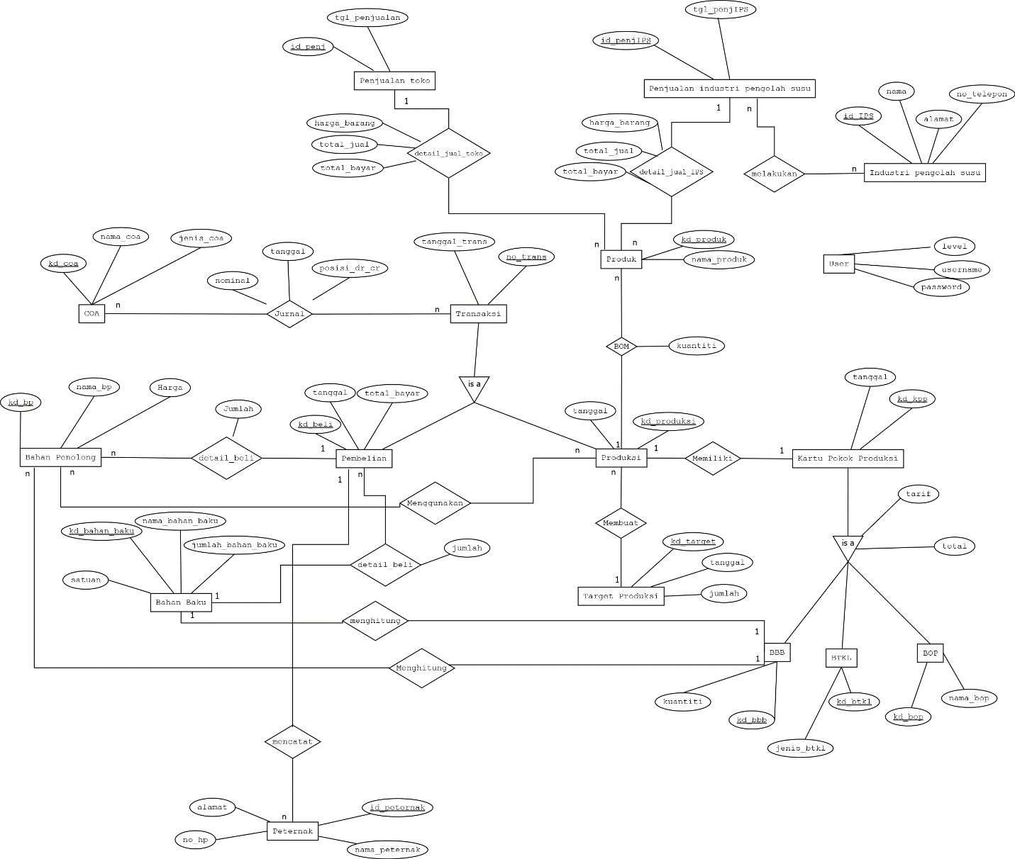

|  |  |  |  |  |
| --- | --- | --- | --- | --- |
| No | Nama Tabel | Atribut | Tipe Data | Keterangan |
| 1. | akun | No_akun | Varchar(11) | PK |
|  |  | Nama_akun | Varchar(30) |  |
|  |  | Header_akun | Varchar(11) |  |
|  |  | Id_trans | Varchar(11) | FK |
|  |  | No_akun | Varchar(11) | FK |
| 2. | jurnal | Posisi | Varchar(11) | PK |
|  |  | Tanggal | Date |  |
|  |  | Nominal | Int(30) |  |
|  |  | No_akun | Varchar(11) | FK |
| 3. | Transaksi | Id_trans | Varchar(11) | PK |
| Tanggal | Date |  |
| Total | Int(11) |  |
| 4. | Penjualan Toko | Id_penj | Varchar(11) | PK |
| Tgl_penjualan | Varchar(11) |  |
| 5. | Detail_penjualan_toko | Harga_barang | Int(11) |  |
|  | Total_jual | Int(11) |  |
|  | Total_bayar | Int(11) |  |
|  | Id_trans | Varchar(11) | FK |
|  |
|  |
| 6. | Penjualan Industri Pengolah Susu | Id_penjIPS | Varchar(11) | PK |
|  |  | Tgl_penjIPS | Date |  |
|  |  | Id_IPS | Varchar(11) | FK |
| 7. | Industri Pengolah Susu | Id_IPS | Varchar(11) | PK |
| Id_penjIPS | Varchar(11) | FK |
| Nama | Varchar(11) |  |
| Alamat | Varchar(11) |  |
| No_telepon | Int(11) |  |
| 8. | Produk | Id_produk | Varchar(11) | PK |
|  |  | Nama_produk | Varchar(11) |  |
|  |  | Stok | Varchar(11) |  |
|  |  | Id_trans | Varchar(11) | FK |
| 9. | Bahan_baku | id_bahan_baku | varchar(11) | PK |
| nama_bahan_baku | varchar(30) |  |
| jumlah_bahan_baku | int(11) |  |
| Satuan | varchar(30) |  |
| 10. | Peternak | Id_peternak | varchar(11) | PK |
| Nama_peternak | varchar(11) | FK |
| No_hp | int(11) |  |
| Alamat | Varchar(11) |  |
| Id_beli | Varchar(11) | FK |
| 11. | bahan_penolong | kd_bp | varchar(11) | PK |
| nama_bp | varchar(30) |  |
| Harga | int(11) |  |
| 12. | detail beli | Kd_beli | varchar(11) | FK |
| Kd_bp | varchar(11) | FK |
| Kd_bb | Varchar(11) | FK |
| Jumlah | Int(11) |  |
| 13. | Pembelian | kd_beli | varchar(11) | PK |
| kd_bp | varchar(11) | FK |
| Kd_bb | Varchar(11) | FK |
| Tanggal | Date |  |
| total_bayar | int(11) |  |
| 14. | Produksi | kd_produksi | varchar(11) | PK |
| Tanggal | Date |  |
| 15. | target_produksi | kd_target | varchar(11) | PK |
| kd_produksi | varchar(11) | FK |
| Tanggal | Date |  |
| Jumlah | int(11) |  |
| 16. | Produk | kd_produk | varchar(11) | PK |
| nama_produk | varchar(11) |  |
| 17. | detail_kpp | kd_kpp | varchar(11) | FK |
| Kd_bbb | Varchar(11) | FK |
| kd_btkl | varchar(11) | FK |
| kd_bop | varchar(11) | FK |
| Tarif | int(11) |  |
| Total | int(11) |  |
| 18. | Kartu Pokok Produksi | kd_kpp | varchar(11) | PK |
| Tanggal | Date |  |
| Subtotal | int(11) |  |
| 19. | BBB | kd_bbb | varchar(11) | PK |
| Kuantiti | int(11) |  |
| 20. | BTKL | kd_btkl | varchar(11) | PK |
| Jenis_btkl | varchar(30) | FK |
| 21. | BOP | kd_bop | varchar(11) | PK |
| nama_bop | varchar(100) |  |
| 22 | BOM | kd_produk | varchar(11) | FK |
| kd_produksi | varchar(11) | FK |
| Kuantiti | int(11) |  |
| 23. | Detail_jual_IPS | Id_penjIPS | varchar(11) | FK |
| Harga barang | Int(11) |  |
| Total_jual | Int(11) |  |
| Total_bayar | Int(11) |  |
| 24. | User | Username | varchar(30) |  |
| Password | varchar(100) |  |
| Level | varchar(30) |  |